How to create an account for the Student/Parent Portal
(This is only applicable for grades 7-12 students.
Please contact your school for Kindergarten to grade 6 students)
If you are a Golden Hills student, you do not need to create an account. You need to use your network username and password to access your information.
Select the PowerSchool link on your School’s Website.
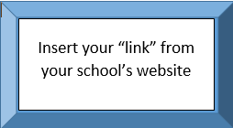
Selecting the PowerSchool link will take you to this screen to sign in. You can also get to the log in screen by entering sis.ghsd75.ca into any browser. If you already have an account enter your username and password.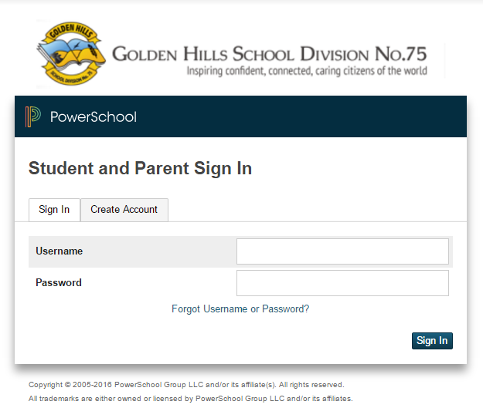
Use this tab if you need to “Create Account”
Fields to use for parent or student accounts that have already been set up.
Use this tab if you need to “Create Account”
“Create Account tab” will take you to this screen.
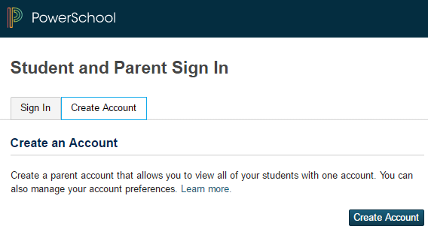
Choose “Create Account” button
Create Parent Account
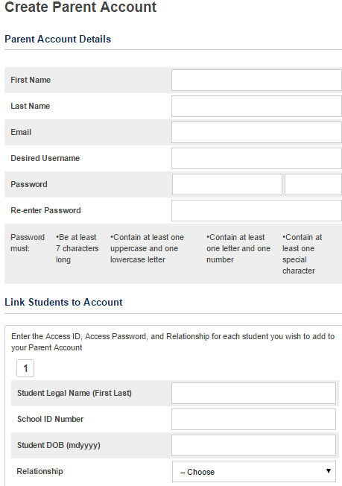
74
11

9

10

8

61

5

4

3
2

1
Follow the below steps:
- Enter your first name.
- Enter your last name.
- Enter the email address you will use for the School to contact you.
- Enter a user name you wish to use when logging in.
- Enter your desired password based on the requirements listed.
- This will show you a barred indicator as to how strong a password you have created.
- Re-enter your password.
- If you have more than one child, even in multiple schools, this is where you enter each child's information; starting with their legal first name and last name.
- Enter the School ID Number for the student. It can be found on a printout of their timetable or report card. It is not their ASN, Alberta Student Number
- Enter your child's date of birth using mdyyyy format – January 1, 2001 would be 112001 or December 31, 2009 would be 12312009.
- Indicate your relationship to the student.
If you have more than one child attending a school in GHSD, begin again at step 8. There will be an Enter button at the bottom right of the screen to select when your entries are complete.

